
English Department.
Teacher: Andrea Mendoza Campos.
missmendozacampos@gmail.com
2020

Worksheet Invitations
Name: Grade: IV grade ___ SE |  |  | Date:
Objective: To create an invitation.
Unit 1: Our World.
Topic: Invitations

Instructions:

- Read the invitation and answer the questions in your copybook.



  - What kind of invitation is it?
It is a wedding celebration
  - Who are inviting to the celebration?
Paula and Steve
  - Where does the celebration take place?
Transversal Grange Bar & Restaurant
  - When does the celebration take place?
On Saturday 14th November 2009
  - What time is the celebration?
It is at 7.30 pm

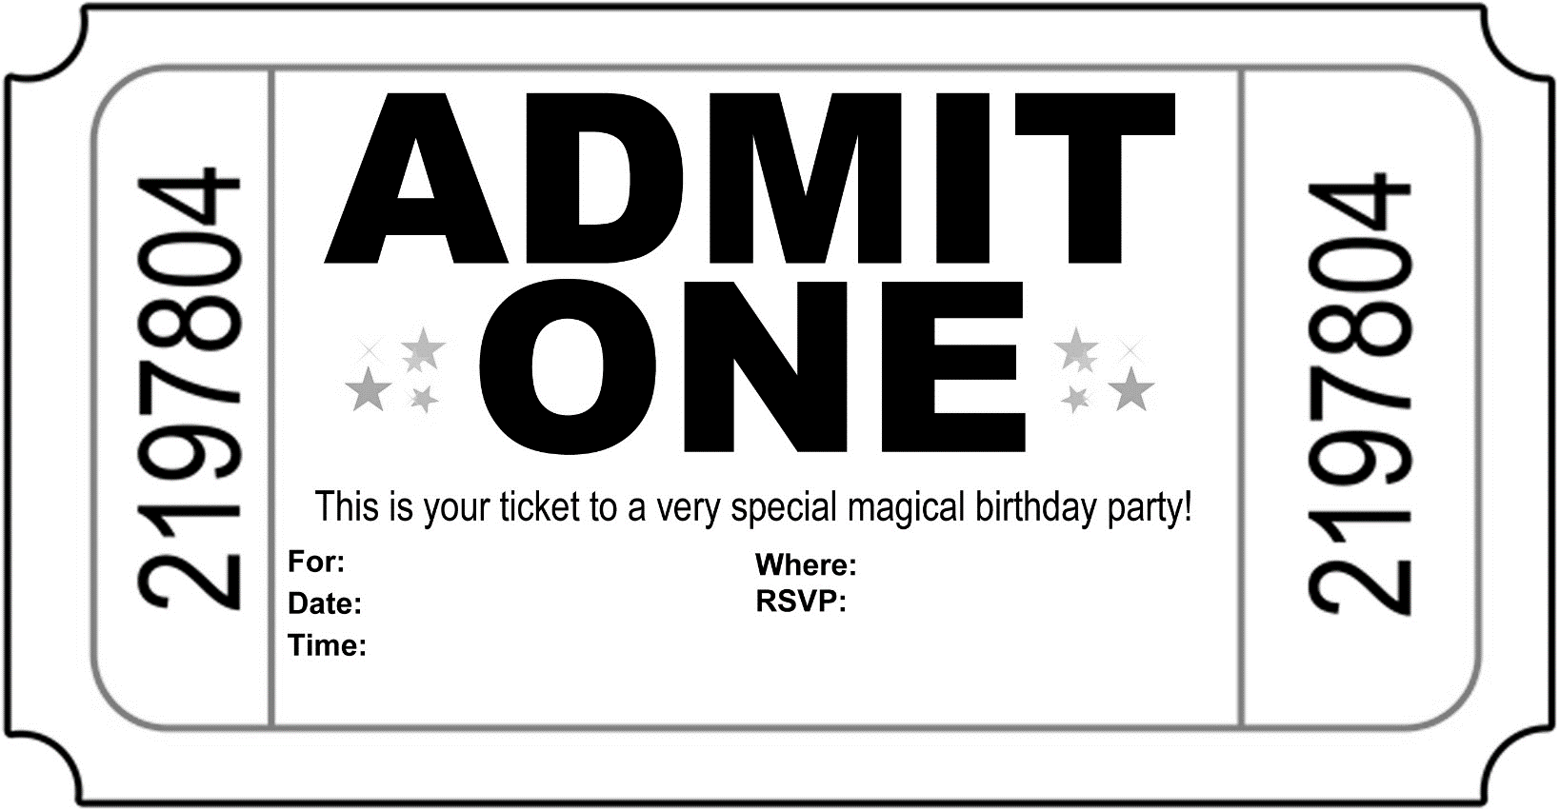
- Full fill the following invitation template.
Jennifer Palma
March 22nd
8.30 pm
Barbaras´avenue 1
+56971227825

- Create an invitation using a ppt template or canva, for canvas program use the following link: https://www.canva.com/es_es/crear/infografias/

